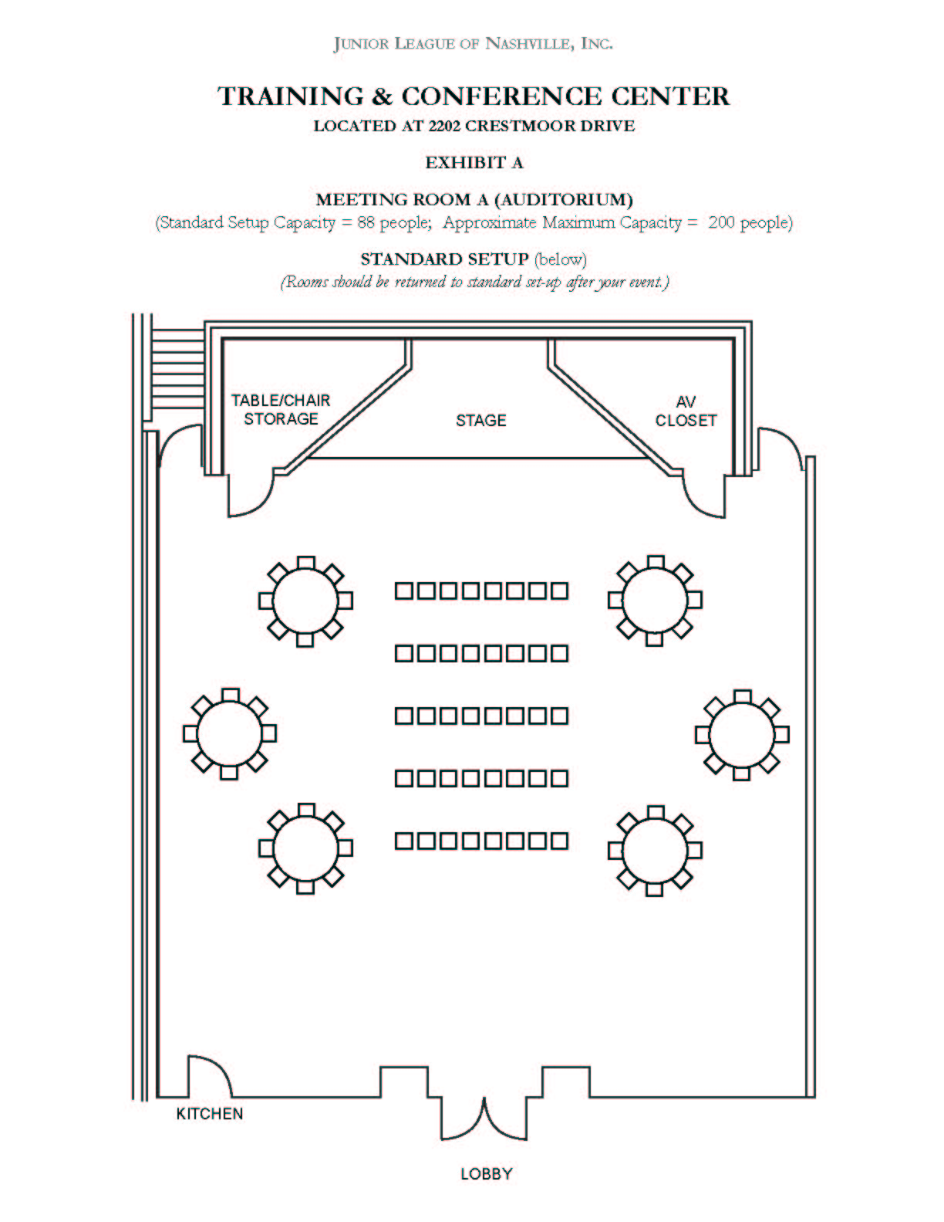

EXHIBIT A
Junior League of Nashville Headquarters
FEE AND DEPOSIT SCHEDULE

AUDITORIUM

Less than Four (4) Hours Per Day
Meeting Space | Usage Fee | Deposit | Sq. Feet | Approx. Max. Capacity
Room A (Auditorium) | $300 | $150 | 2205 | Theater set-up 230

Four (4) to Eight (8) Hours Per Day
Meeting Space | Usage Fee | Deposit | Sq. Feet | Approx. Max. Capacity
Room A (Auditorium) | $500 | $250 | 2205 | Theater set-up 230

More than Eight (8) Hours Per Day
Meeting Space | Usage Fee | Deposit | Sq. Feet | Approx. Max. Capacity
Room A (Auditorium) | $600 | $300 | 2205 | Theater set-up 230

CONFERENCE ROOM
Full Day - Eight (8) Hours Per Day
Meeting Space | Usage Fee | Deposit | Sq. Feet | Approx. Max. Capacity
Room B (Conference Room) | $300 | $150 | 760 | 51

CONFERENCE ROOM
By the Hour
Meeting Space | Usage Fee | Deposit | Sq. Feet | Approx. Max. Capacity
Room B (Conference Room) | $50/hour | One half of the amount for hours requested | 760 | 51

